Geluidenatlas (Sound Atlas)
Artistic research on semantics for sound towards an invitation to enrich our listening culture.

"The limits of my language mean the limits of my world" Wittgenstein

1
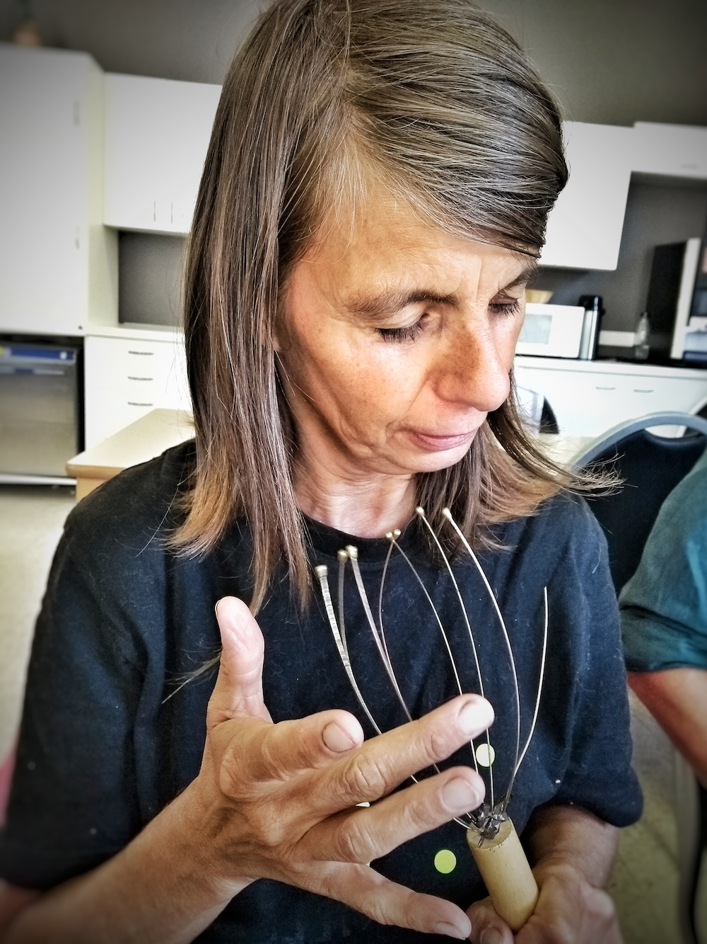
Blind and visually impaired people have - out of necessity - a much richer listening culture.
By clicking within echolocation, acoustic effects provide more information about the distance, the shape and the material of an object (eg. car, wooden door,…). Which are not unimportant tools in daily life for blind fellow human beings…

In addition to orienting, blind people also listen to the emotionality and intensity within the sound. For example, by listening to the pace at which someone is walking up the stairs, is he in a hurry or frustrated, does her knee still hurts,… ?!

Seeing people, in general are much less aware of this qualities of listening.

2
Due to the fact that we live in a very visual world, we have developed little language around listening and sounds.

In terms of acoustics, for example, there are few concepts available besides “dry” and “wet”, while there are many more nuances between the reflections of a clicking sound (cfr. echolocation) on glass or on water. It can come down to saving dry feet ...

In concrete terms, the listening and language poverty in sighted people often results in appalling acoustic environments (cf. classrooms, receptions, landscape offices, ...), but also within urban planning, for example, no thought is given to how we live together aurally, while they still create the soundscape of the city with their interventions.

3
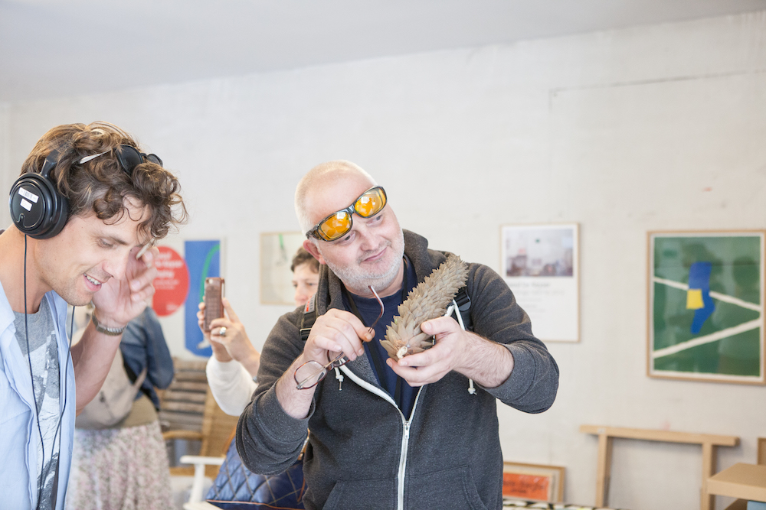
With Geluidenatlas we want to create a tool that makes navigating in a world full of sound easier in everyday life for both blind and sighted people. Blind and partially sighted people take the lead in this artistic collaborative research project.

We can measure volume and frequencies, but timbres and textures of sound are more difficult to determine. Which words, terms and concepts does our dictionary provide us? Can we work with the language of the music producers? Or aural designers who design the sound of the doors of a BMW? Can the vocabulary of sommeliers, the perfume organ of perfumers or taste matrices of q-graders in coffee help us to describe sounds?

We learn one thing from the taste and odor research: language can never describe all sounds. As a tool, the Geluidenatlas will provide more useful categories that provide guidance.

4

I want to confront the Walk-Listen-Create café with the urgency of this problem and the lack of semantics of sound.
After a brief overview of the participative work of 15 year aifoon, I’ll reveal our plans and some inspirational thoughts on the process and the tool we want to develop, but I’m also curious how other people would approach this problem? How do other cultures and/or languages deal with this problem of poverty? And what can we learn from other sectors?

Let’s brainstorm loudly!

Bio Stijn
After his studies in philosophy and mixed media, Stijn Dickel worked as a musician-performer together with Jan Fabre. He also composed various sound compositions for dance, theater, circus and documentary. He is artistic director and listening artist at aifoon vzw, an art organization that investigates the relationship between listening and movement / being moved through collaborative projects and productions.

www.aifoon.org

